Meaningful Image Descriptions

For Social Studies Content
  - More Resources to Help Write
Image Descriptions

Teacher Editions of Textbooks
If you are creating braille based on a print textbook, search for a Teacher Edition. Within these versions, there are often additional clues or descriptions that could help create the braille image description.

Alternative Text
If you are creating braille based on online content, search for "alt text", or alternative text associated with images. These short descriptions will be read by a screen reader if the student is accessing the materials online. These descriptions could be perfect for braille, or a good starting point.

How to Find Alt Text
One way to hear the provided alternative text is to explore the online content using a screen reader. You can also use Google Chrome as your web browser to find and copy the available alt text to your braille file. Simply right click on the image and click "Inspect."
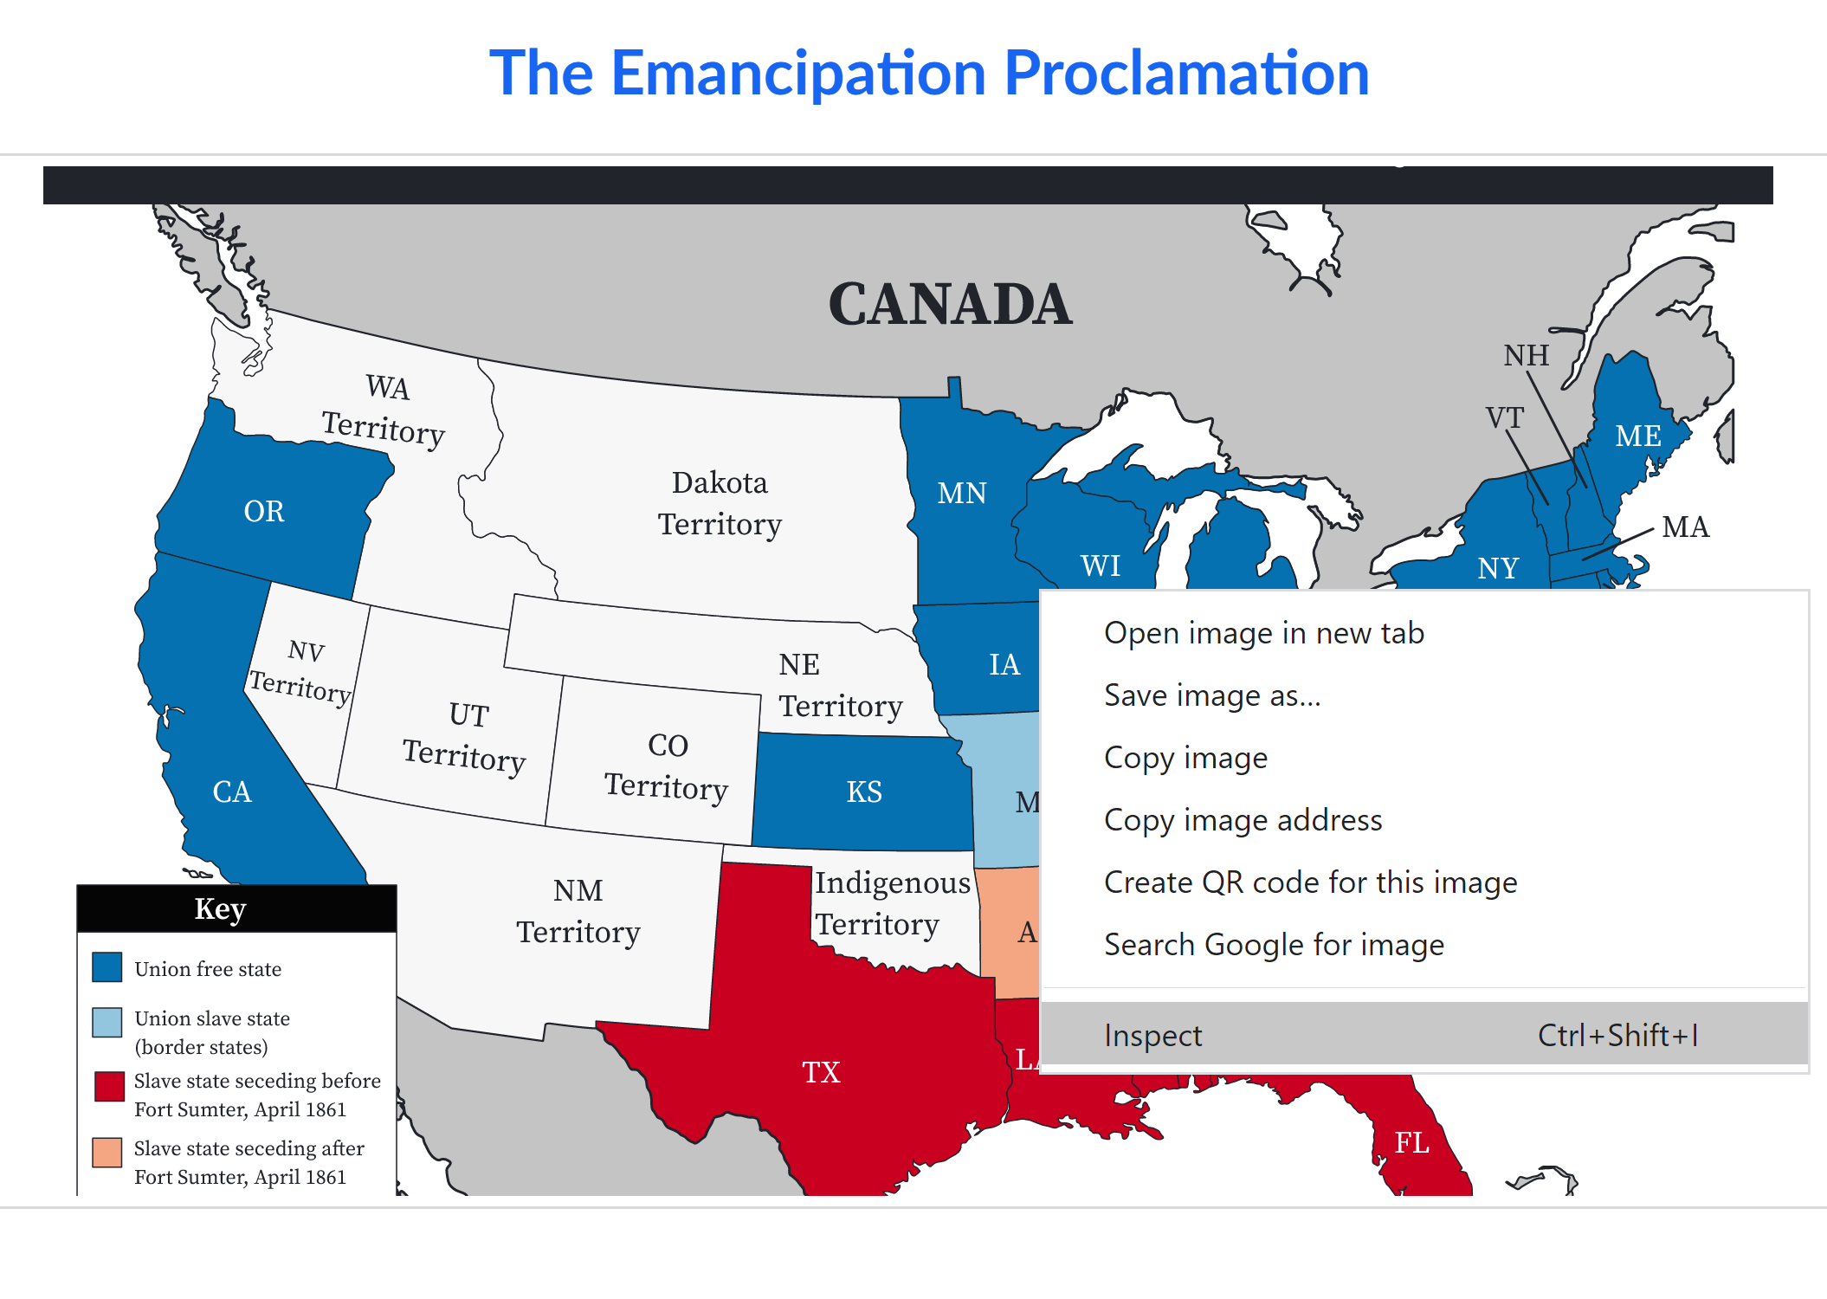
This will open a menu along the right side of your browser window showing all the Developer Tools. The information associated with the image should be highlighted, including any available alternative text. If the field reads alt="" there is no provided alt text.
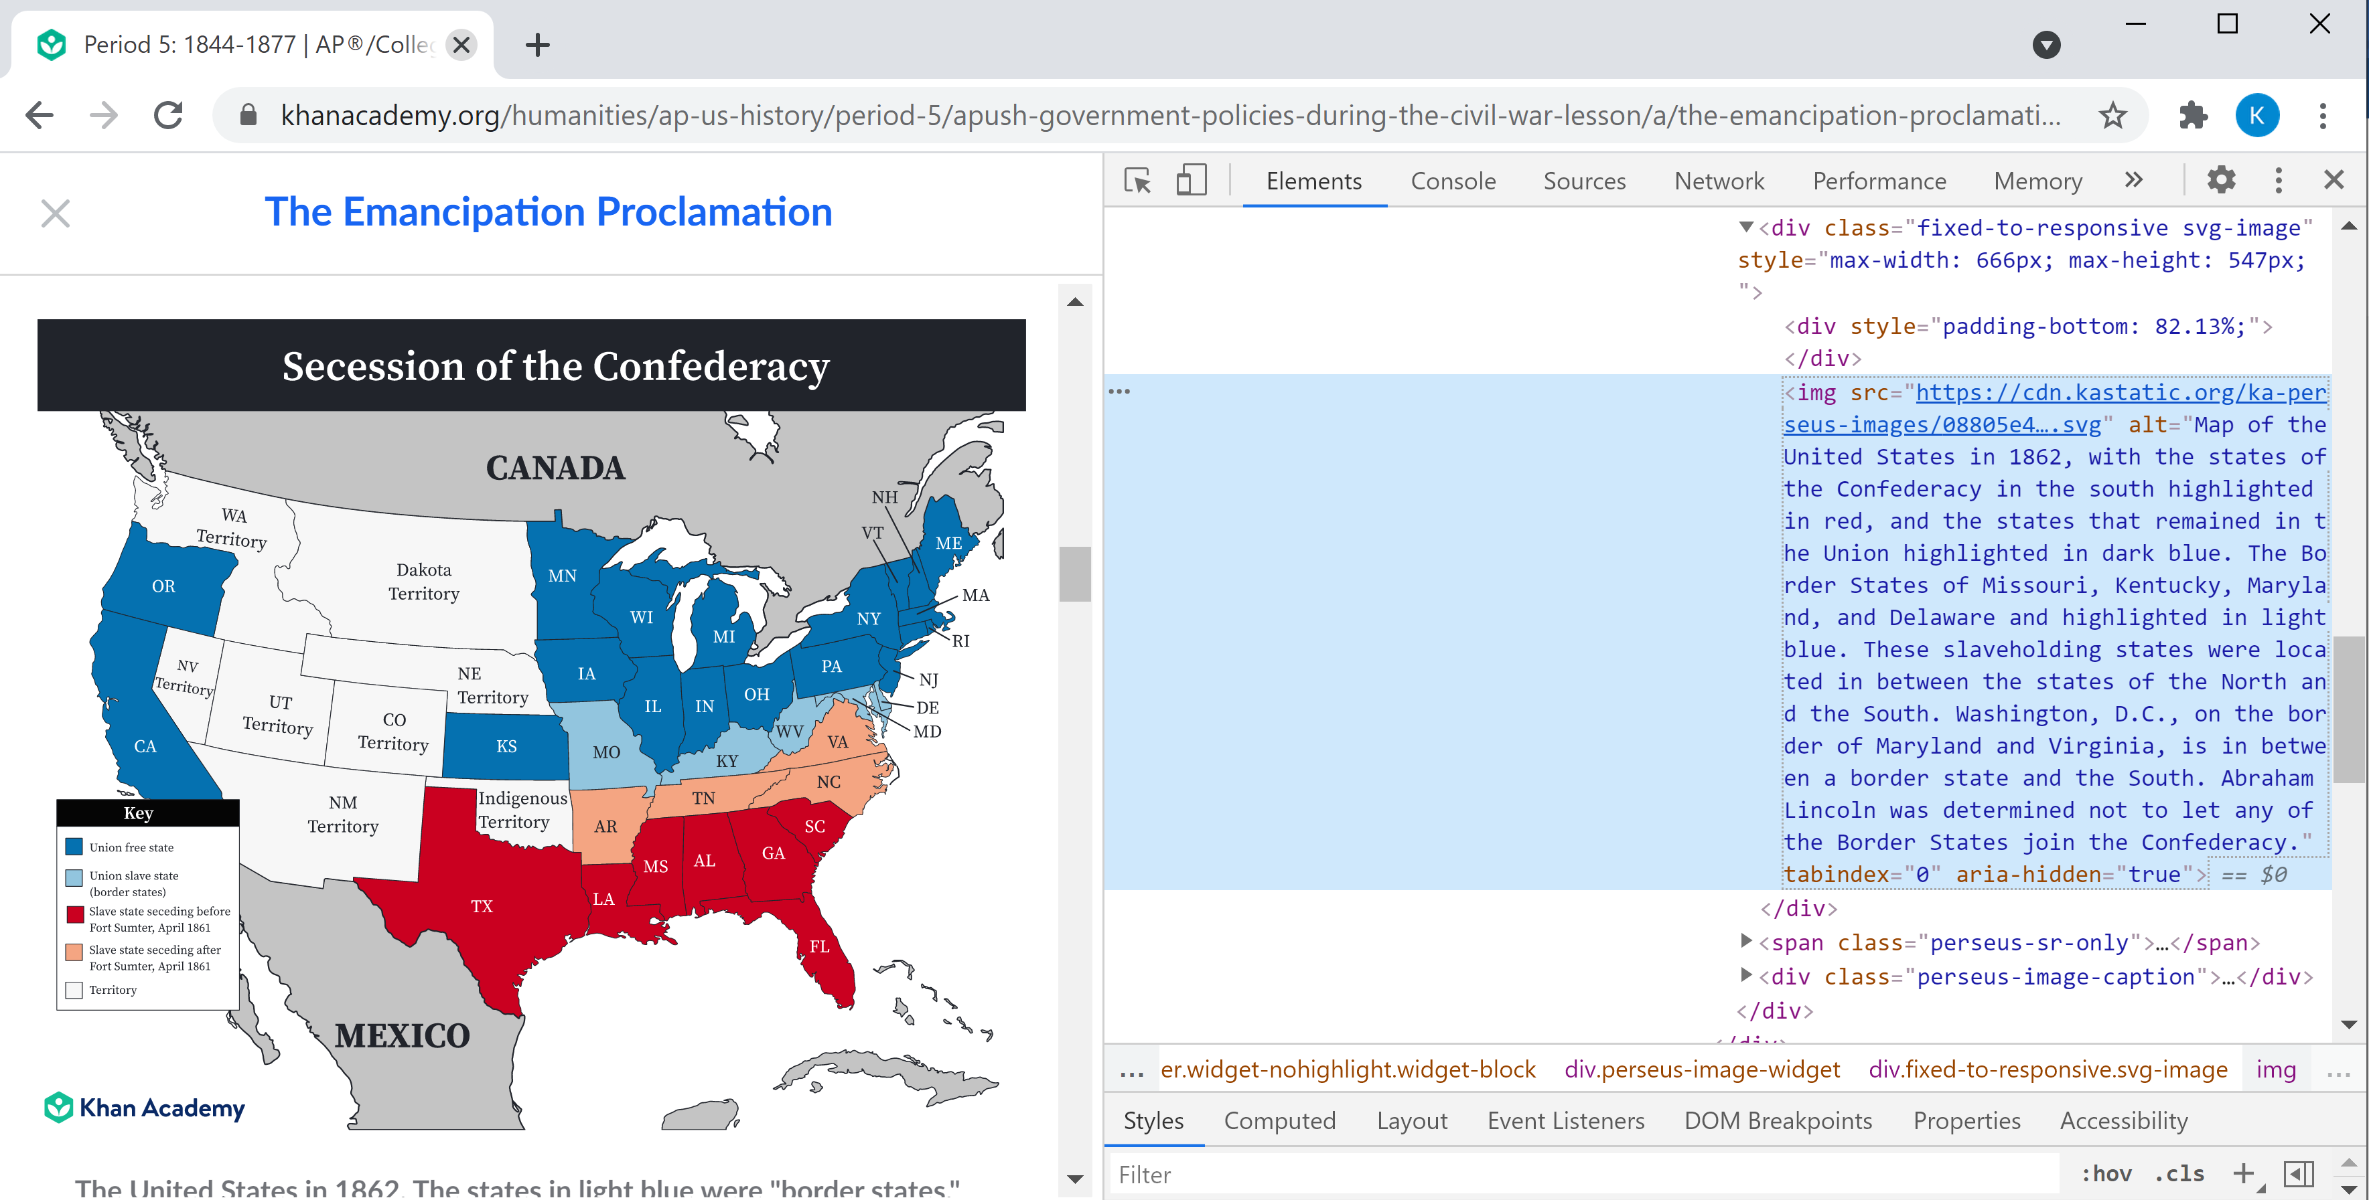
In order to easily see all the text and alter it for your braille file right click again on the image information in the Developer Tool menu, or click the three small dots to the left of the image information. Select "Copy" and then "Copy Element." You can also use the keyboard shortcut of Ctrl+C.
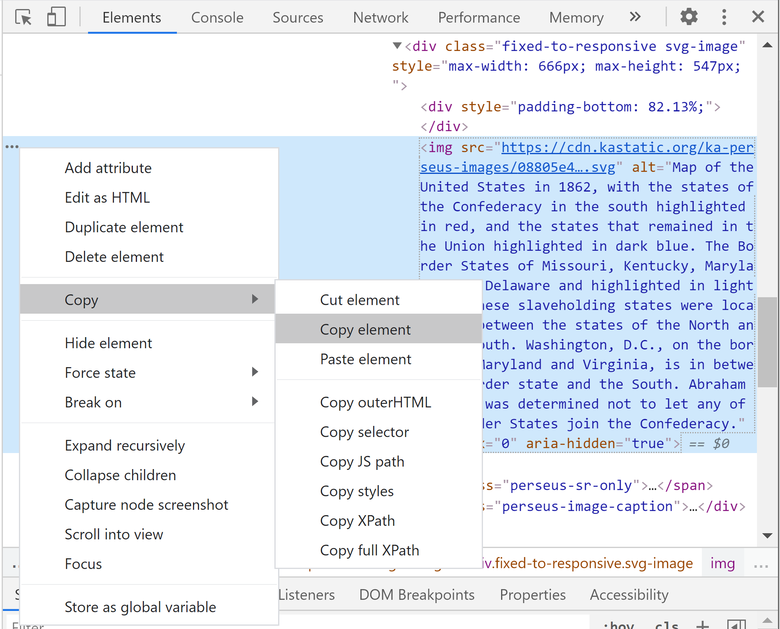
You can then paste the information into whatever text-based file you are using to create the braille and edit it appropriately, removing the extra information about the image. Remember, the developer didn't write the alt text specifically with blind and visually impaired students in mind, so the image description could possibly be improved.

Ask for Help
There is no shame in asking for another person's opinion. In fact, it is very helpful for testing out image descriptions. If you share the description with another person, can they understand what you are trying to convey? If they are struggling to visualize what you're describing, you might need to make some edits so the student has a better chance of comprehending what appears in print.
If the content itself has you stuck, don't hesitate to ask someone who might know more. The teacher assigning the material or another teacher in the same subject area can be a big help, or even another transcriber. Perhaps they've seen something similar and can offer suggestions.
If you are lucky enough to know the student for whom you are creating braille, consider asking for their opinion. With time, and trial and error, you might learn how the student prefers to receive descriptions. With so many formatting options, their preference could help simplify the writing process.

Consult a Trustworthy Website
If the content still has you stuck, there are resources online that can help you learn more, and possibly offer details to help you write a description.

Khan Academy
www.khanacademy.org has many courses focused on social studies content

Encyclopædia Britannica
www.britannica.com/study/is the home of the encyclopedia maker's Student Center, featuring tons of resources on history

Smithsonian Institute
www.si.edu features more information on paintings, sculptures, and other objects invaluable to U.S. History

Library of Congress
www.loc.gov contains a massive catalog of content that includes photographs, political cartoons, and more from U.S. History

Consider a Manipulative
If the description still isn't conveying the print, a manipulative might be a better option.

3-D Printing

For statues, architecture, and other objects from history, a small, three-dimensional rendering of the object could be more informative and enjoyable for the student to explore.
www.thingiverse.com has files for 3-D printing created and uploaded by users available for free. Be sure to read all the details before printing, as results can vary!
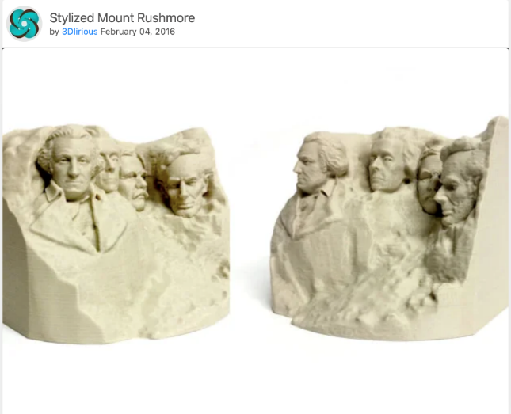

Existing Products
APH offers many products available with Quota Funds focused on social studies content.
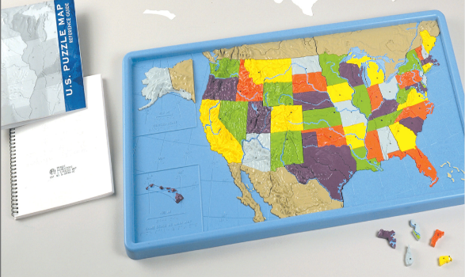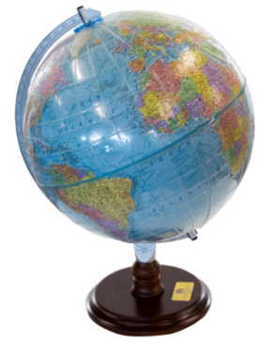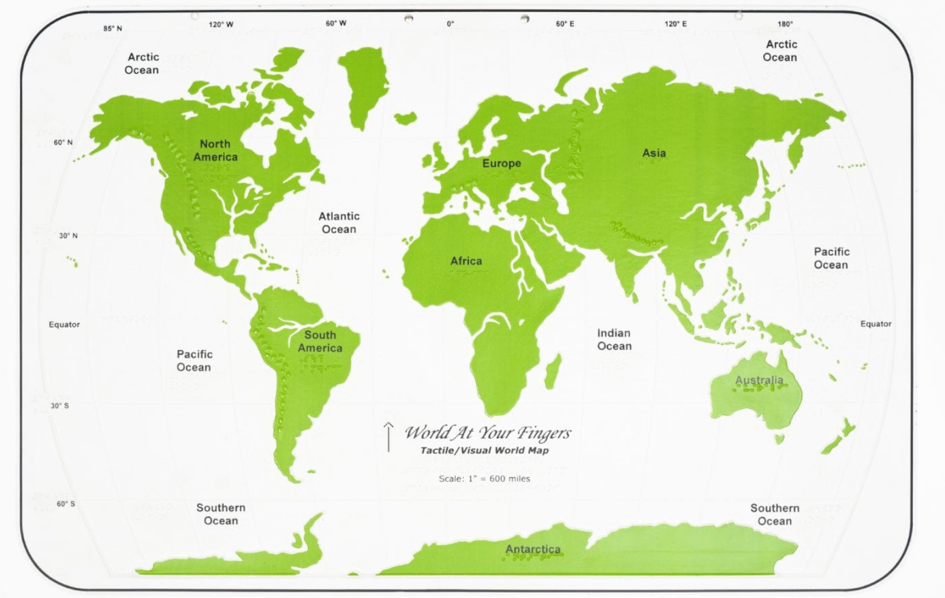
U.S. Puzzle Map – a political and topographic puzzle of the United States with reference guide https://www.aph.org/product/u-s-puzzle-map/
Tactile World Globe – an overlay that fits any existing 12" globe, complete with braille labels and key https://www.aph.org/product/tactile-world-globe/
World at Your Fingers – a tactile map of the world plus additional maps https://www.aph.org/product/world-at-your-fingers/
Check out the APH Product Catalog for more ideas! https://nyc3.digitaloceanspaces.com/aph/app/uploads/2020/06/09134953/APH-Products-Catalog.pdf

Consider a Description AND a Tactile
Studies have shown improved comprehension when braille readers are provided with both a tactile graphic and an image description. If you aren't familiar with the student's learning style, or you feel either option alone is unclear, consider using both. While it might seem like twice the work, it is worth twice the reward! There are existing resources to help you quickly create social studies tactile graphics.

APH Tactile Graphic Image Library
Free to use once you sign up, there are many maps and social studies content ready for you to build upon to quickly create useful tactile graphics. https://imagelibrary.aph.org/aphb/

Perkins Paths to Technology
The teacher created Resource Library offers a variety of content, including social studies graphics ready to emboss. https://www.perkinselearning.org/technology/teacher-created-resource-library

Other Guidance for Writing Image Descriptions

DIAGRAM Center
Image Description Guidelines http://diagramcenter.org/table-of-contents-2.html
Accessible Image Sample Book http://diagramcenter.org/accessible-image-sample-book.html
Training (Videos, PowerPoints, Documents) http://diagramcenter.org/making-images-accessible.html#imagetraining

BANA Guidelines
Braille Formats, Principles of Print-To-Braille Transcription, 2016 http://www.brailleauthority.org/formats/2016manual-web/frontmatter.html
Guidelines and Standards for Tactile Graphics, 2010 http://www.brailleauthority.org/tg/web-manual/index.html

