Plan a Treasure Hunt
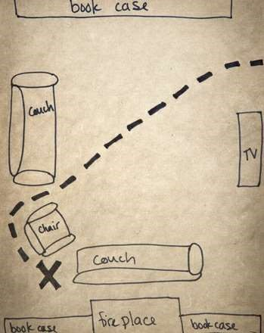
What young kid could resist the pull of an outdoor adventure, and the promise of hidden treasure? This treasure hunt for preschoolers is the perfect way to combine the two. It's easy to turn your home or backyard into a faraway land with secrets to unfold—set the stage, and your kid's imagination will do the rest. In between all that bounty-chasing and treasure-digging, he'll get a taste of how to use a map, and begin to connect how images and symbols on a map correspond to things in the physical world
What You Need:
- Small token to serve as the treasure (This can be anything, from a toy from the dollar store to a handful of small rocks coated with a metallic spray paint to resemble gold or silver coins)
- Small paper bag
- Black felt pen
- Sheet of white paper
- Pencil (colored pencils work too)
- Coffee grounds or black tea (optional ) Lighter or matches (optional)
(The picture is of a map that has the following items labeled: couch, tv, chair, a second couch, bookcase and fireplace and an X to mark the spot of the treasure.)
What You Do:
1. Bundle your rocks or other treasure in the small paper bag and write a bold X on the Outside. Aaarg, matey!
2 Once you've got your pirate booty lined up, choose your location—lnside or
Out—for the hiding Spot. Hide the treasure well, but make Sure it won't be too hard for your child to discover
- Now it's time to make the treasure map. This can be as simple or elaborate as you wish, but remember, your child will need to read it independently in order to find the treasure. Keep words to a minimum and use pictures to the max. Let your artistic side shine, but don't get too intimidated—this is just silly pirate fun! A simple sketch Of the area where the treasure can be found is sufficient, with an X marking the spot Of the booty
- If you have the time, consider creating a more authentic-looking map by soaking the white paper in coffee grounds or black tea.
TO give the paper a brittleness, try drying it in a 200⁰ oven. For a truly special touch, carefully burn the edges Of the paper with a lighter or matches
- Once you've got the main locations on there (bushes, the house, a favorite tree), add a dotted line that shows the path for finding the treasure. This is a visual cue to reinforce simple directions
Now sit back and enjoy watching your child's excitement as he uses the clues provided on the map to find the treasure. Amid the pure pirate fun, he'll get an intro to map reading
Pirate-themed birthday bash coming up? This is the perfect outdoor activity to keep the little scoundrels occupied
copyright © 2020 Education.com LLC All Rights Reserved

