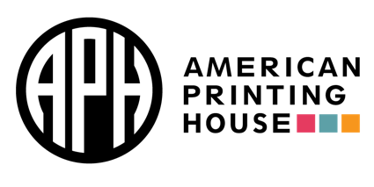

APH Resources
- Outreach Services
- APH HIVE
- National Prison Braille Network
- Museum
- Migel Library
- Hall of Fame
- InSights Art Contest
- Typhlo & Tactus Competition
- Accessibility Hub
- NIMAC
- Louis Database
- Tactile Graphics Image Library
- Braille Tales program

Registrations Links for Virtual Learning
Registration for Access Academy events: https://www.aph.org/educational-resources/training/access-academy/
Registration for Connect Center events: https://aphconnectcenter.org/webinars/
Registration for Partner Showcase events: https://www.aph.org/partner-showcase/
- APH’s YouTube Channel

APH ConnectCenter
- The APH Information & Referral Hotline
  - 1-800-232-5463 (U.S. and Canada) staffed M-F 8:00AM-8:00PM EST
- Email: connectcenter@aph.org
ConnectCalendar

Hive courses in Assessment Category:
Evaluating Independent Living Skills Using the Functional Skills Assessment

Evaluation and Treatment of Children with CVI

From Evaluation to Instruction Using the Barraga Visual Efficiency Program

Hive Course on the MantisQ40

Products
Access Technology
Chameleon20
Decision-Making Guide
FVLMA Practitioner’s Guidebook Braille
Goin’ On a Bear Hunt
Hop-A-Dot
MantisQ40
NewT Kit
Reach and Match
Splish the Fish
Six Little Dots

Access Academies: JAWS with Google
JAWS with Google Docs
https://www.youtube.com/watch?v=avAFBR1ckv8
JAWS with Google Classroom
JAWS with Google Classroom
JAWS with Google Slides
JAWS with Google Slides

Leslie Weilbacher
Outreach Specialist – Northwest Region
American Printing House for the Blind
aph.org
lweilbacher@aph.org

